**How To Create Report Templates In Dashboard:**

Dashboard report templates can be created and saved for later use to allow for efficient reporting.

For this example we will use the **Booked Business Report**.

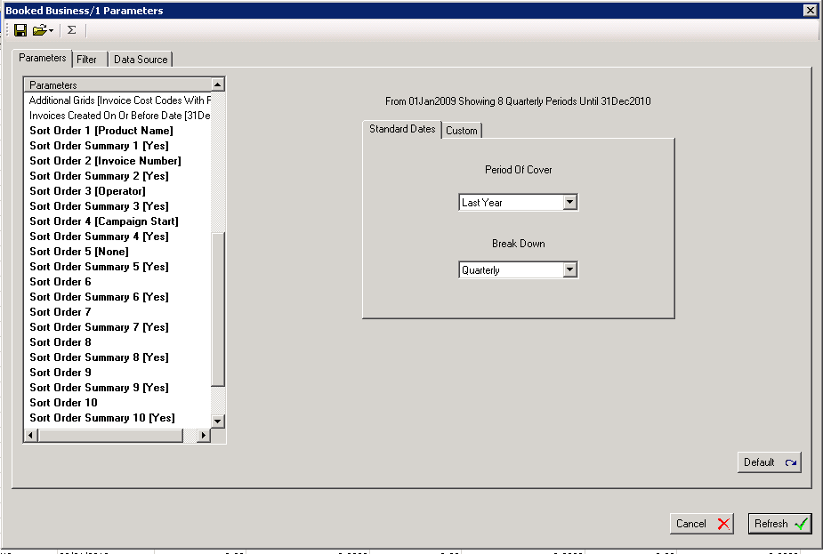

1. Select your **Parameters**. Contract Number, Advertiser Name, Agency Name, Media Product Type, Media Product Name, Sales Person Name and Operator From Inv Line were selected for this example.

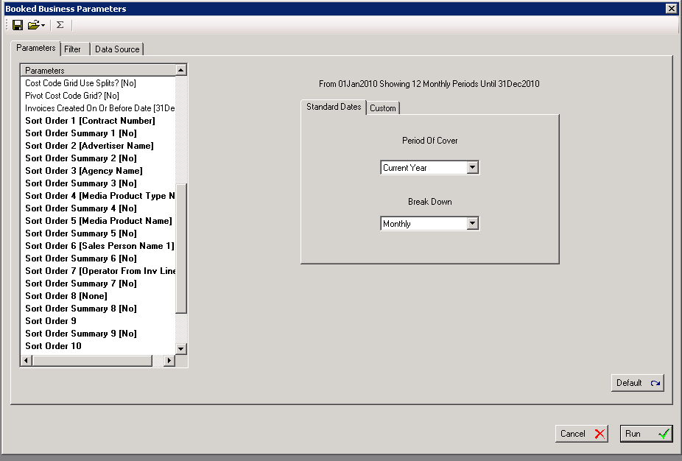

1. Select your **Filters**. Media Product Type Name was selected for Bus in this example.

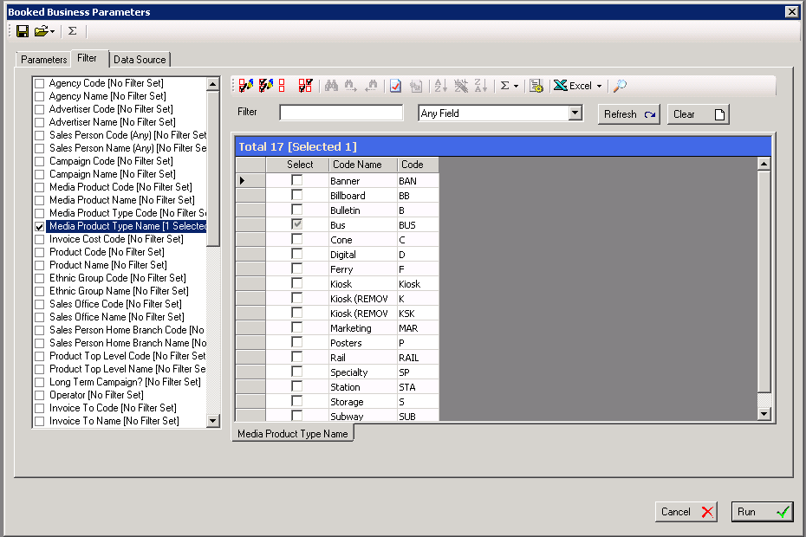

1. Click **Paramater Save** (Floppy Disc Icon). Enter title of Parameter Template, an example would be **NJ-Bus**. Select **Ok**. These templates are created globally so ensure name is descriptive.

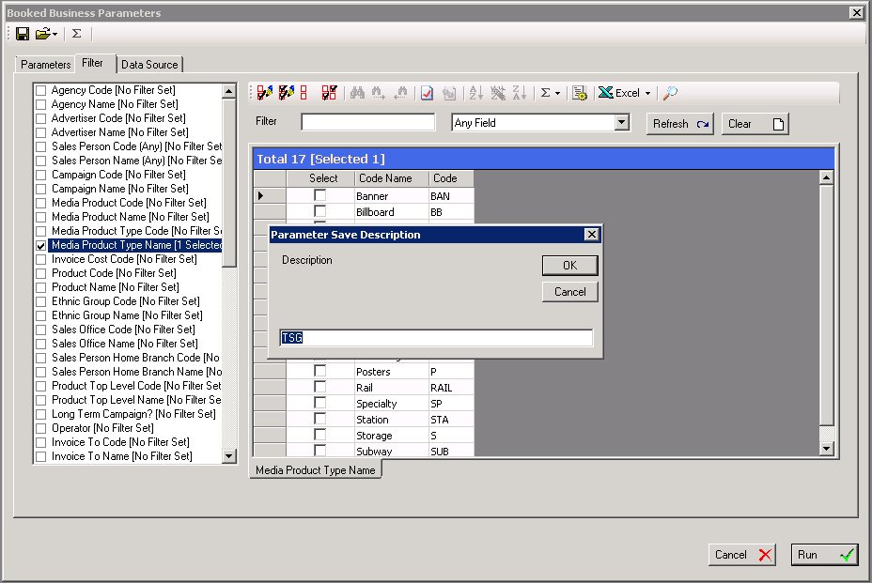

1. Next Time you go into your report go to the folder drop down menu select your **Paramater Template**. Double click on Template, our example is **TSG**.

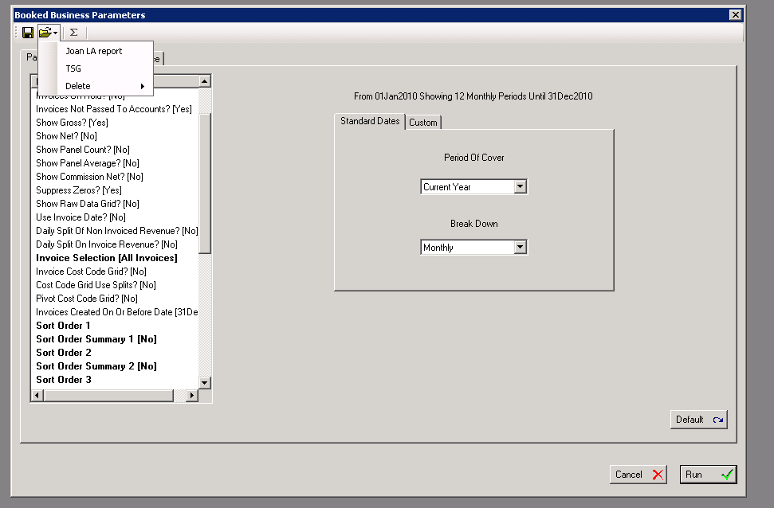

1. Your Parameter Template will populate. Apply any desired changes and run your report.

